Trekking (Trip B)
Paksong – khamsone Coffee plantation –Tad Moun – B Bang

Itinerrary:
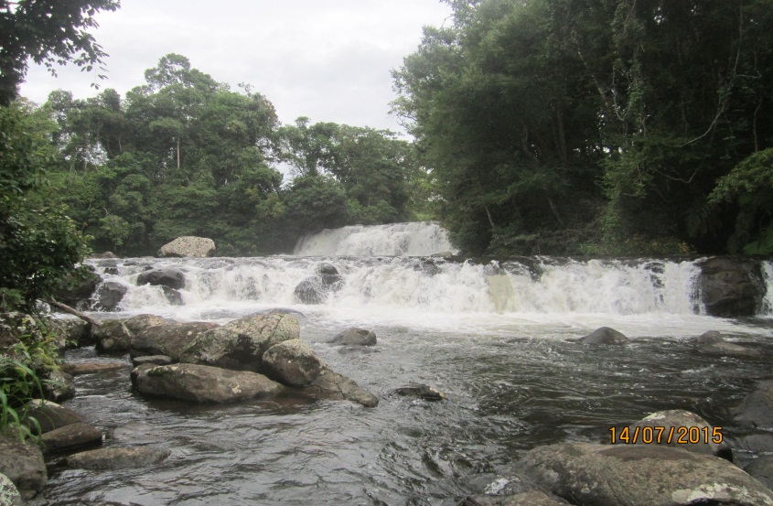
9h.00 am: Arrival at Paksong. Car changing from minivan to the Jeep! Then take the road to khamsone Coffee farm: 13km/30min by bumpy + muddy road (in rainy season)
9h.30 am Arrival at khamsone coffee farm where you can see Mr. khamsone an English speaking guide and the coffee farm owner will take 1hrs to give explanations and demonstrations about coffee from planting to roasting steps, finishing by a coffee tasting to savor the different kind of coffee (Robusta, Arabica and Typica)
10h.30 am: Trekking along the coffee plantations 45min to the top of Volcano mountain named (Phu Sanak) and enjoy your taking photos the panorama view of Bolaven plateau before continue the trek to Phu Katok where the American army shooting to the Vietcong in 1965 – 1973.
11h.30 pm: Continue your trek to Tad Moun water fall 2 km/1hrs on the way you can see many vegetable fields like gingers, Cucumbers, Cabbages, Lettuces,chili ...etc.
12h.30 pm: Arrival Tad Moun waterfalls then take a picnic & enjoy your times to swim or relaxing time 2hrs. (Fruits and beverages be provided).
14h.30 pm: After enjoy your time at Tad Moun water fall then continue your trek to Tad Mearlouk waterfall before transfer to B. Beng
16h.30 pm: Arrival at B. Beng and End of service

Remark: This trip can do all year round
Tour Price per person :
All Rates are net in USD:
Rates are per person in a party of:
3 pax | 4 - 6 pax | 7-9 pax up
70 USD/pax | 60 USD/pax | 50 USD/pax

Tour included: What to bring:
- Transportation as mentioned - Swimming clothes
- Mosquito repellent - Sun-cream
- Rain coat - Hat
- Drinking water
- Meals
- English speaking guide
- Coffee and tea

